2Ccircle2:

網路形狀:6

Learning rante:0.01

Epochs:500

Accuracy :1.0

Trainset accuracy:1.0

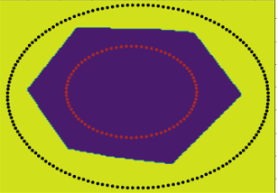

2Circle1:

網路形狀:12  
Learning rante:0.001

Epochs:1000

Accuracy :0.937

Trainset accuracy:1

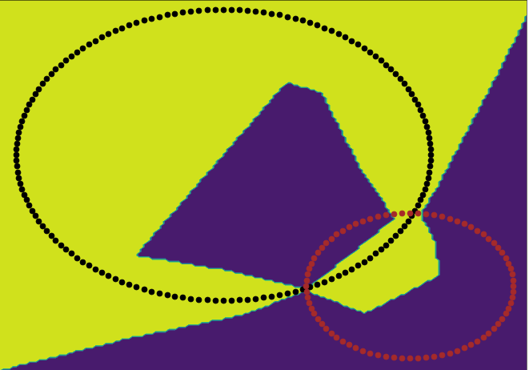

結果不夠好可以設定成2000epochs 試試看

2Circle2:

網路形狀:12  
Learning rante:0.01

Epochs:1000

Accuracy :0.919

Trainset accuracy:0.913

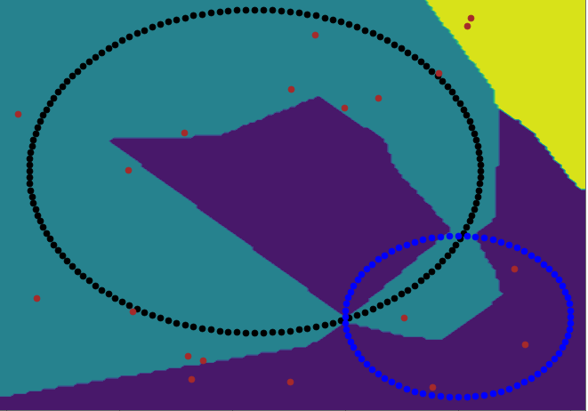

結果跟初始值 and trainset有很大的關係

2CloseS:

網路形狀:2  
Learning rante:0.01

Epochs:10

Accuracy :1

Trainset accuracy:1

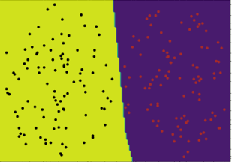

2CloseS2:

網路形狀:4  
Learning rante:0.1

Epochs:50

Accuracy :1

Trainset accuracy:1

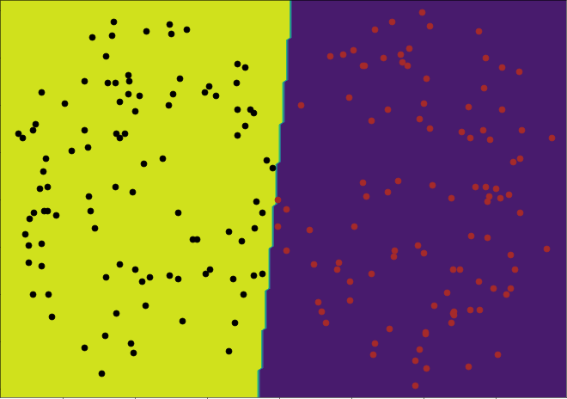

2CloseS3:

網路形狀:4  
Learning rante:0.1

Epochs:50

Accuracy :1

Trainset accuracy:0.998

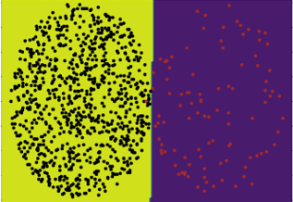

2cring:

網路形狀:2

Learning rante:0.02

Epochs:100

Accuracy :1

Trainset accuracy:1

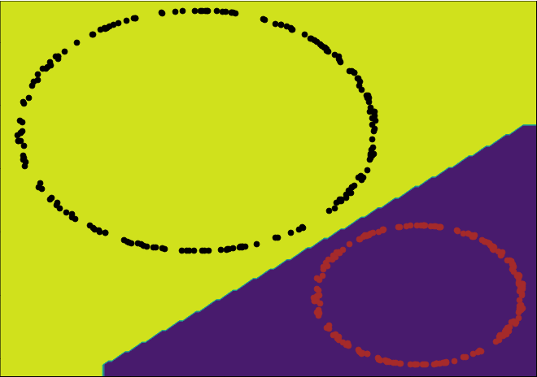

2CS:

網路形狀:2

Learning rante:0.01

Epochs:20

Accuracy :1

Trainset accuracy:1



2Hcircle1:

網路形狀:4

Learning rante:0.05

Epochs:100

Accuracy :1

Trainset accuracy:1

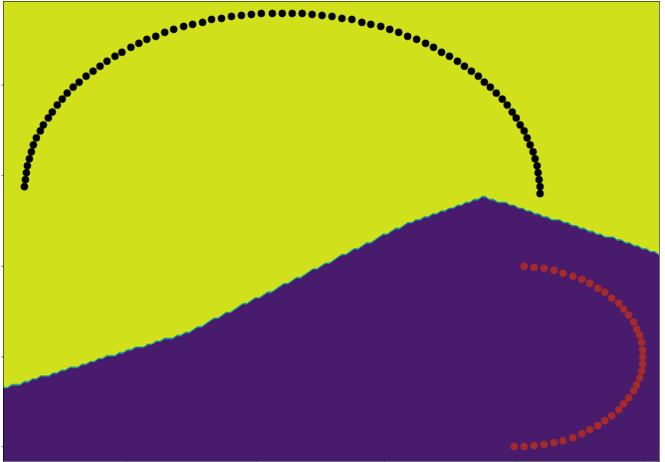

2ring:

網路形狀:2

Learning rante:0.02

Epochs:100

Accuracy :1

Trainset accuracy:1

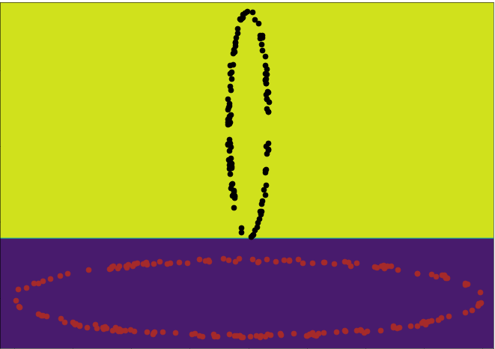

Perceptron1:

網路形狀:2

Learning rante:0.1

Epochs:20

Accuracy :1

Trainset accuracy:1



Perceptron2:

網路形狀:6

Learning rante:0.05

Epochs:500

Accuracy :1

Trainset accuracy:1



4satellite-6:

網路形狀:12

Learning rante: 0.00005

Epochs:800

Accuracy :0.831

Trainset accuracy:0.846

一開始沒有把資料做正規化，正確率大概只有0.4左右，把dataset中range 比較大的幾項做正規化後，可以跑到0.825，有明顯的改善，因為模型效能沒有很好，建議要跑的話Epochs設個300就可以了

8OX:

網路形狀:

Learning rante: 0.0005

Epochs:5000

Accuracy :0.929

Trainset accuracy:1

5closeS1

網路形狀:2

Learning rante:0.01

Epochs:20

Accuracy :1

Trainset accuracy 1

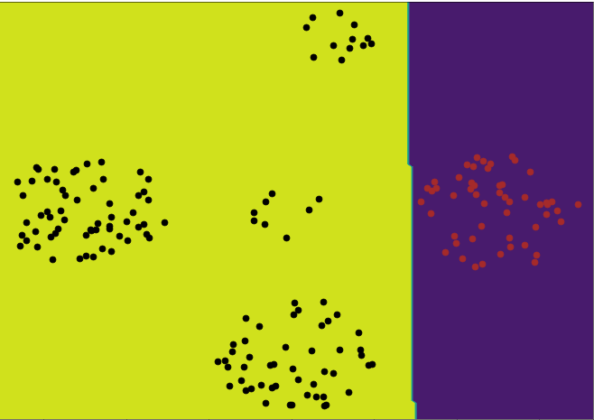

C3D:

網路形狀:4

Learning rante:0.01

Epochs:200

Accuracy :1

Trainset accuracy:1

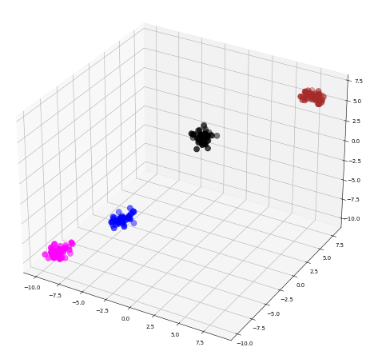

C10D:

網路形狀:2

Learning rante:0.001

Epochs:100

Accuracy :1

Trainset accuracy:1

Iris:

網路形狀:4

Learning rante:0.005

Epochs:500

Accuracy :1

Trainset accuracy:0.98

Number:

網路形狀:3

Learning rante:0.001

Epochs:3000

Accuracy :1

Trainset accuracy:1

Perceptron3:

網路形狀:3

Learning rante:0.05

Epochs:50

Accuracy :1

Trainset accuracy:1

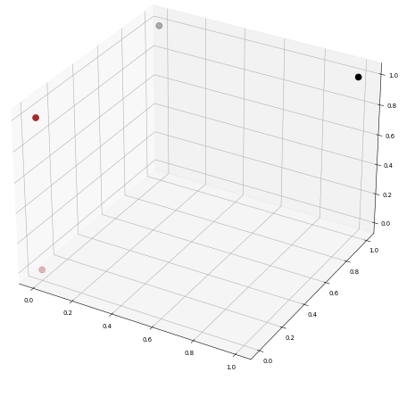

Perceptron4:

網路形狀:3

Learning rante:0.05

Epochs:50

Accuracy :1

Trainset accuracy:1



wine:

網路形狀:3

Learning rante:0.0002

Epochs:2000

Accuracy :1

Trainset accuracy:0.975

初值很重要

xor:



網路形狀:4

Learning rante:0.08

Epochs:500

Accuracy :1



Trainset accuracy:1





我看助教給的pdf其中說明要寫鍵結值，可是有些網路形狀太大鍵結值太多，所以有需要的麻煩助教自己跑看看，我都有在最後輸出鍵結值，像這樣

